DEVOPS PROJECT

# Task 1 - Server Setup and SSH Configuration

## 📌 Objective

Provision a Linux server and configure secure SSH access using key-based authentication.

---

## 🖥️ Environment

* OS: Ubuntu (Virtual Machine)

---
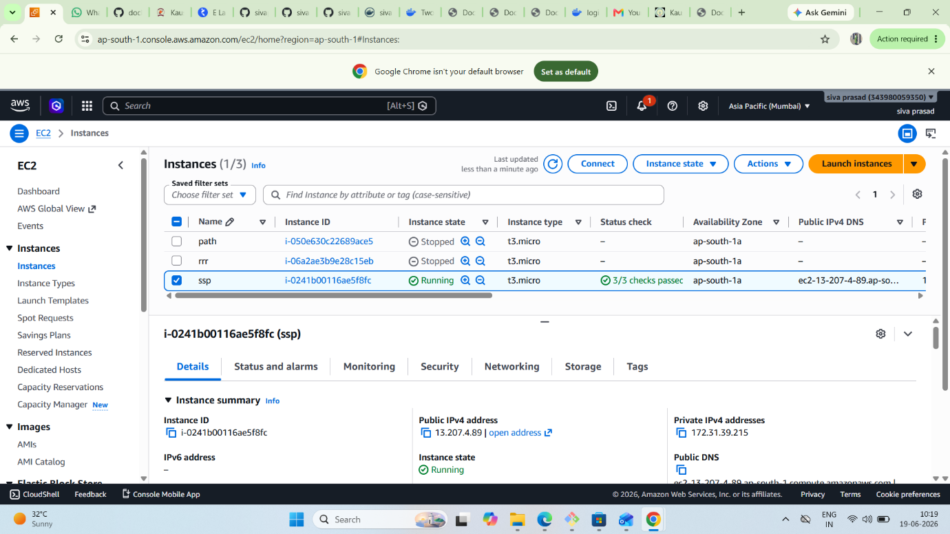
## ⚙️ Steps Performed

### 1. Update System
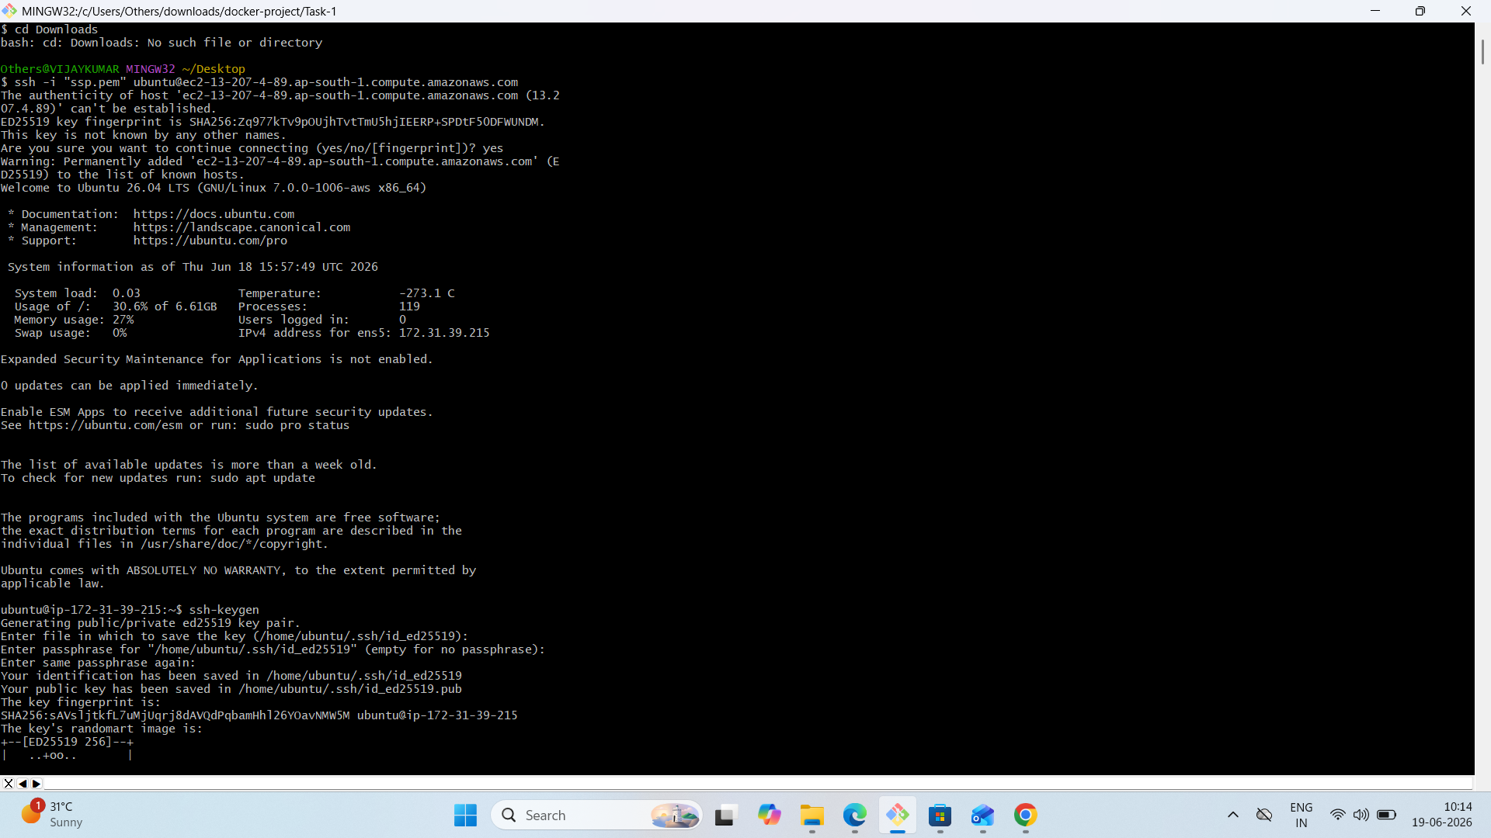
sudo apt update
sudo apt upgrade -y

---

### 2. Install SSH

sudo apt install openssh-server -y
sudo systemctl start ssh
sudo systemctl enable ssh

---

### 3. Check SSH Status

sudo systemctl status ssh
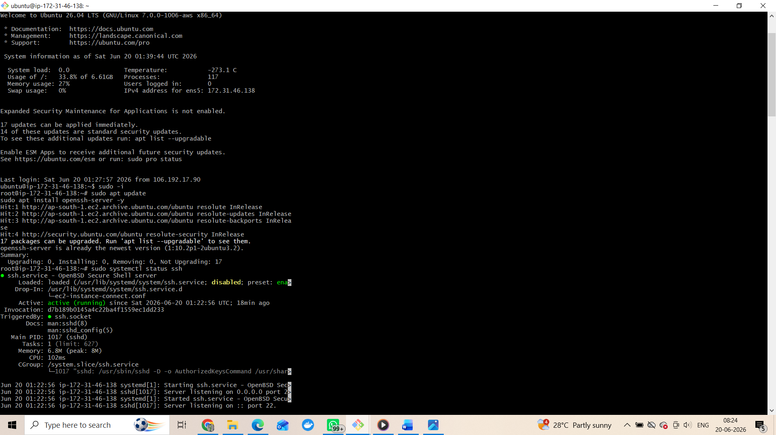
---

### 4. Find IP Address

ip a

---

### 5. Connect via SSH (Password)

ssh username@server_ip

---

### 6. Generate SSH Key

ssh-keygen

---

### 7. Copy Key to Server

ssh-copy-id username@server_ip

---

### 8. Login Without Password

ssh username@server_ip
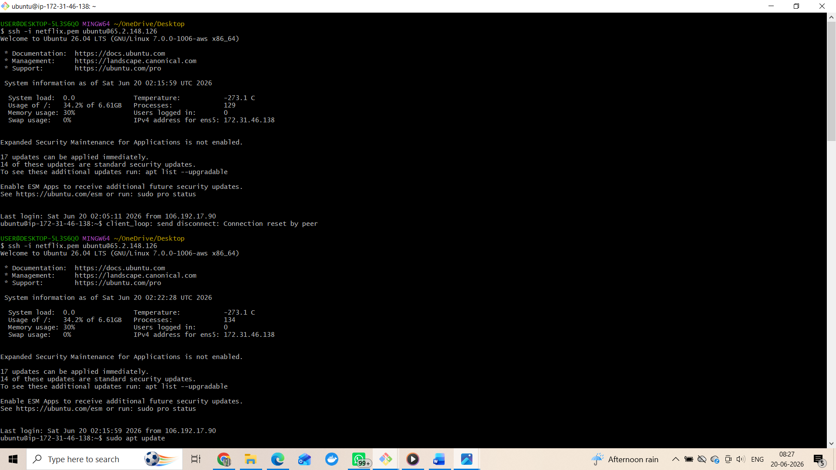
---

### 9. Disable Password Login (Security)

sudo nano /etc/ssh/sshd_config

Change:
PasswordAuthentication no

Restart:
sudo systemctl restart ssh

---

## 🔐 Security Features

* SSH enabled
* Key-based authentication configured
* Password login disabled

---

## 📂 Files Used

* ~/.ssh/id_rsa
* ~/.ssh/id_rsa.pub
* /etc/ssh/sshd_config

---

## ✅ Expected Outcome

Secure SSH login without password using SSH keys.
# Task 2 - DOCKER CONTAINER DEPLOYMENT

## 📌 Objective
Learn basic Docker commands and container usage.

## 🔧 Steps Performed

1. Checked Docker version:
docker --version

2. Pulled nginx image:
docker pull nginx

3. Ran container:
docker run -d -p 8080:80 nginx

4. Checked running containers:
docker ps

## 📷 Output
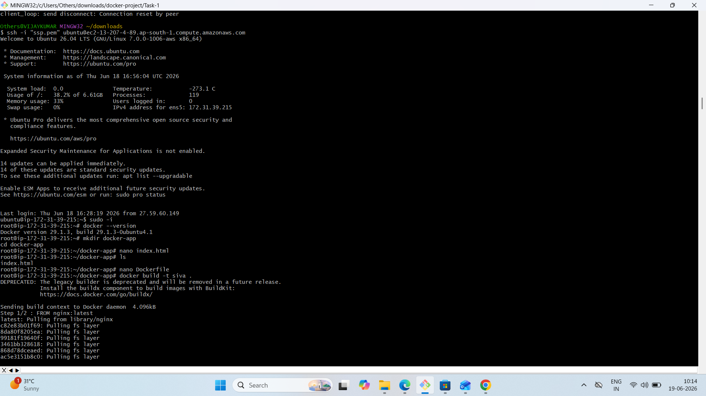

## 📚 Conclusion
Understood how to use Docker to run containers.

# Task 3 - CONTAINER MONITORING LOGS

## 📌 Objective
Create a custom Docker image using a Dockerfile.

## 🔧 Steps Performed

Now I will show container logs with timestamps.
Command:
docker logs <container_id>
OR
bash monitor.sh
This displays logs along with timestamps, which helps in monitoring container activity
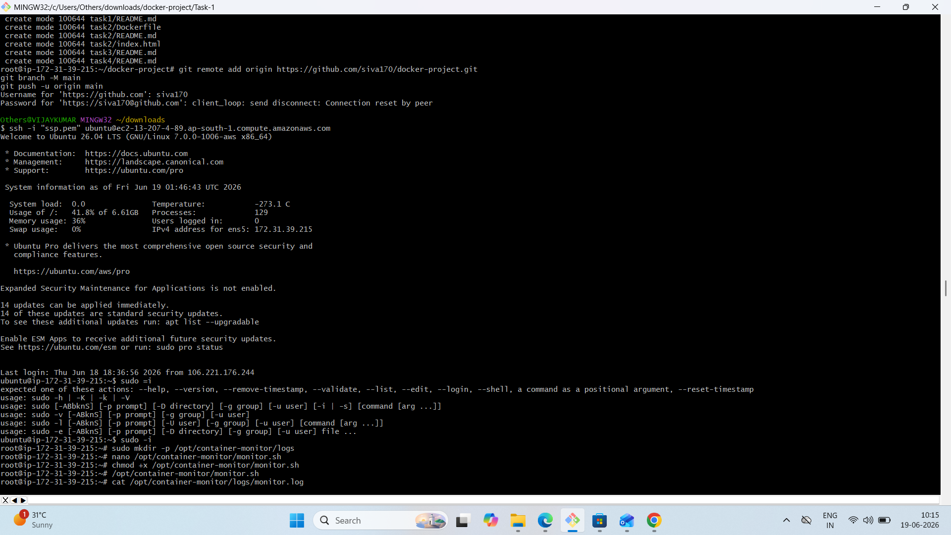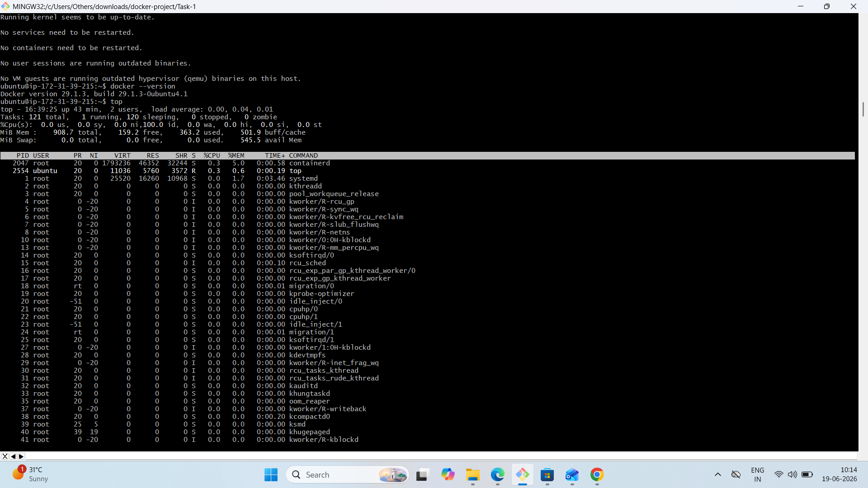

# Task 4 - Secure monitoring logs by restricting access to a dedicated user.

## 📌 Objective
- Create a dedicated user for monitoring operations.
2 . Create monitoring directory: /opt/container-monitor
3 . Assign ownership of monitoring folder to created user.
4 . Provide full access to monitoring user.
5. Restrict access for other users.
6. Verify access control.

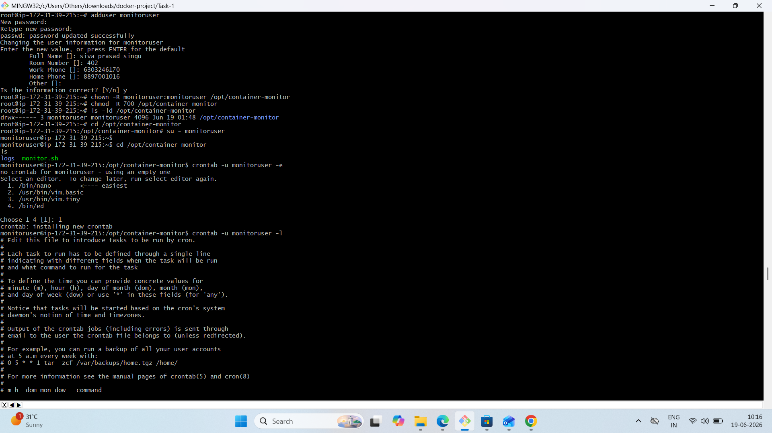

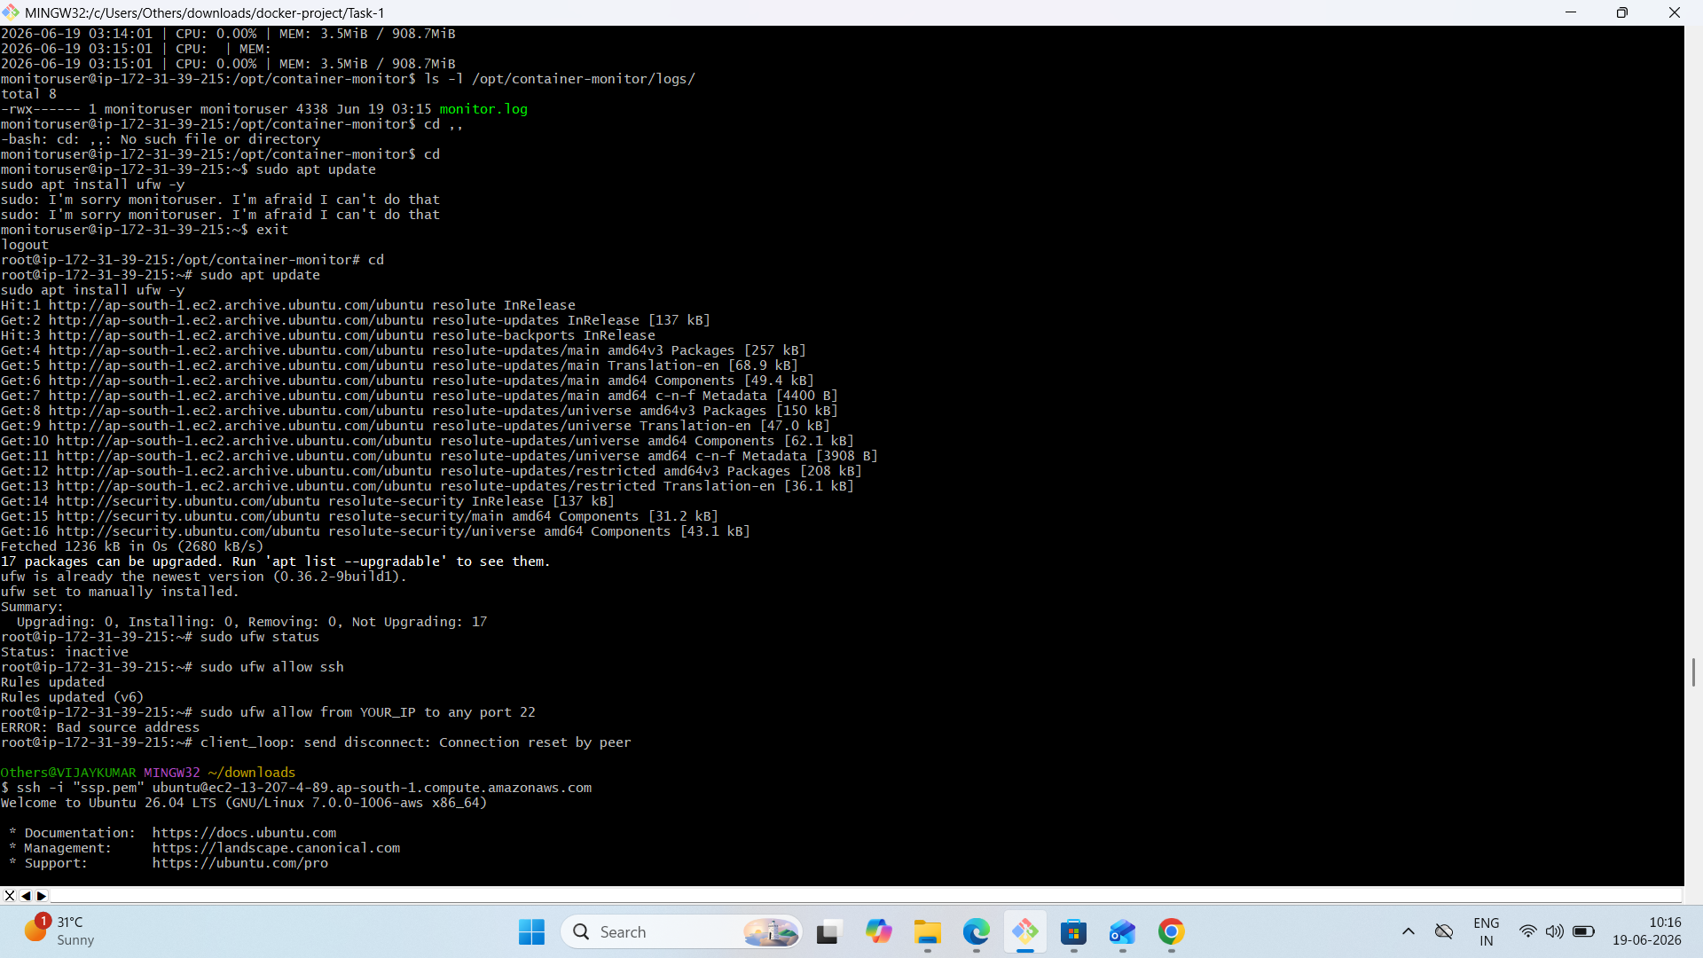

# Task 5 - Firewall Configuration (UFW)

## 📌 Objective
Secure server by restricting SSH access.

## 🔧 Commands Executed

sudo ufw enable
sudo ufw status numbered
sudo ufw delete 1
sudo ufw delete 2
sudo ufw allow from 13.207.4.89 to any port 22
sudo ufw allow 80
sudo ufw allow 8000

## 🔐 Result
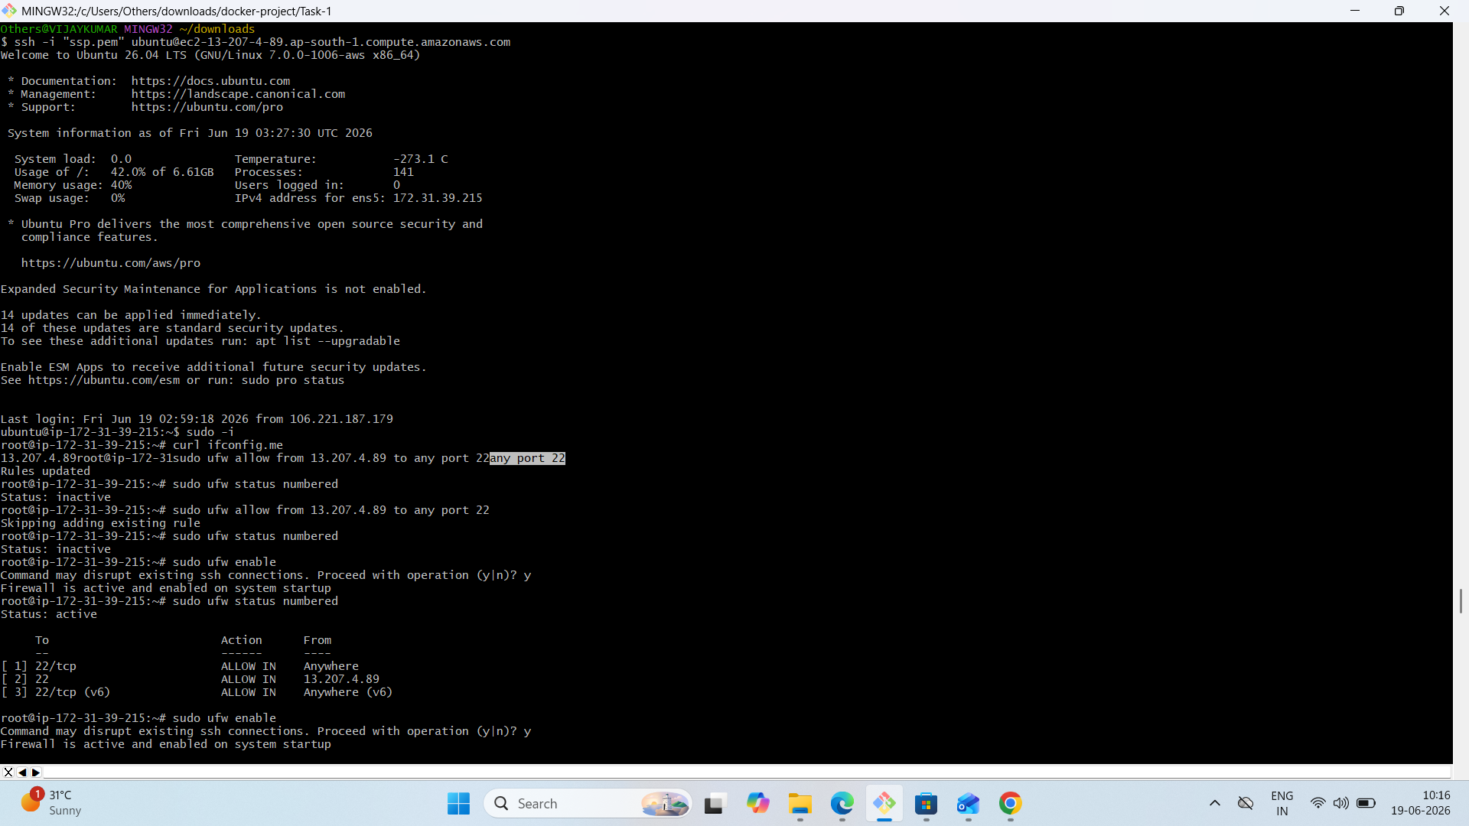

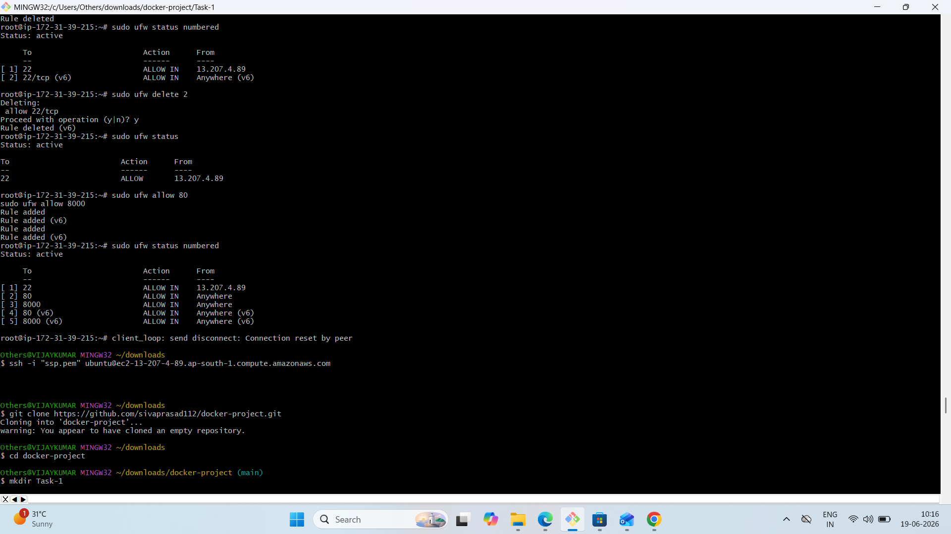

- SSH restricted to specific IP
- Ports 80 and 8000 open

